Assignment #4 - Section 3

**3-1: More with Relationships Practices**

Exercise 1: Resolve M:M Relationships

1.

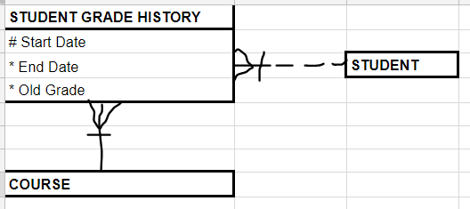

2.

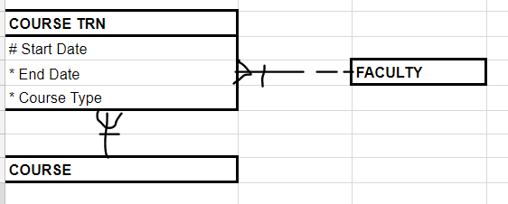

3.

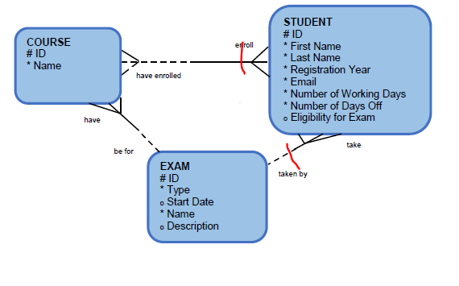

Exercise 2: Adding nontransferability option to an ERD

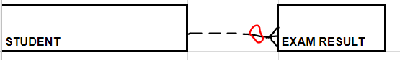

Exercise 3: Identify and draw supertype and subtype entities

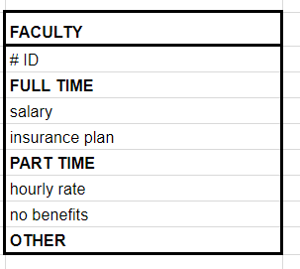

Exercise 4: Examine Exclusive Relationships (Arcs)



Exercise 5: Model Hierarchical Data

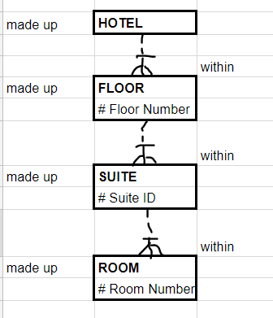

Exercise 6: Model Hierarchical Data and Recursive Relationships

